**Experiment – 2**

Name – ADITYA AGARWAL

Roll No – R171218007

SAP ID:50069294

**Jenkins integration with Github**

1. Start Jenkins using java -jar Jenkins.war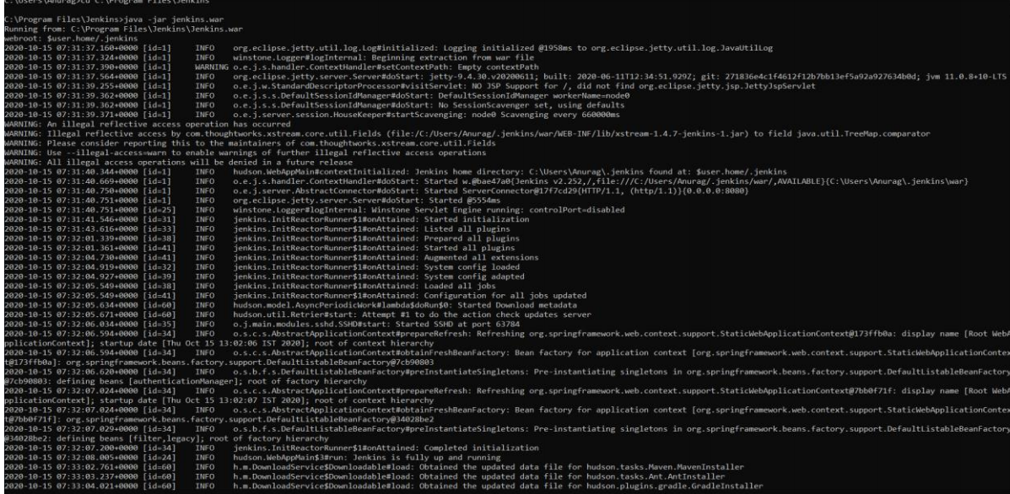
2. Type localhost:8080 and run using Jenkins

3)Click on the new item to create a new freestyle project .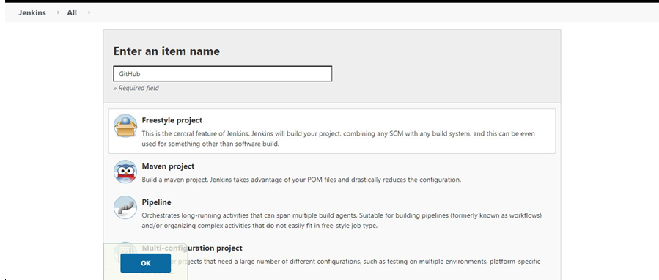

4)Provide URL of github repository and save it.

